Visitor and Engagement Team:
Katie, Carly, Joe, Rose

Strategy:
Engagement Strategies- according to a 2016 study of British museums
- 86% of museums prioritized providing educational opportunities
- 66% prioritized making information on activities and programmes available online
- 64% prioritized making the museum accessible
- 50% prioritized enhancing the visitor experience via mobile services
- 40% prioritized creating quality cross-platform experiences
- 29% prioritized reaching diverse audiences

The AASLH blog argues the “heart of engagement” is giving people a voice. Simple solutions can be the most effective. Claire Blaylock, Executive Director of Clackamas County Historical Society, and her team are testing out white boards, markers, and sticky notes as a way to facilitate feedback and visitor engagement. The AASLH blog also discusses four ways to attract new and existing audiences.
- Tell Specific Stories
- Have a strong hook
- Remember that hands-on experiences make a difference
- Prioritize community engagement

Our Goals: We would like to focus our efforts on hands-on engagement with a variety of age groups. We will accomplish this through interactive displays featuring repeat photography, an interactive beet display, and a physical feedback display.

Ideas:
Beet weighing- interactive
- A live sugar beet? A mock sugar beet? Bag of sugar?
- What weighs as much as a sugar beet?
- How much does a sugar beet weigh?
- Tools from sugar beet manufacturing
This interactive would involve visitors simulating the experience of harvesting sugar beets. We would either use a real sugar beet or a mock-up model of the same average size and weight. There are a variety of ways we can explore this concept, such as having visitors guess the weight of a beet before actually weighing it and trying to lift a beet. We may also have several (fake) beet harvesting tools nearby for visitors to examine and guess the purpose/utility of.

Map pin- backup for space
- AAA map and pushpins from Katie
Although not the most engaging interactive, displaying a map at the beginning or end of the exhibit would allow visitors to share where they are from. It would allow us, the class, to visually see where our visitors have traveled from or moved from, keeping with the theme of movement, migration, and immigration. It would also be flat, taking up minimal space in limited space display areas.

Feedback option- clothesline with pins.
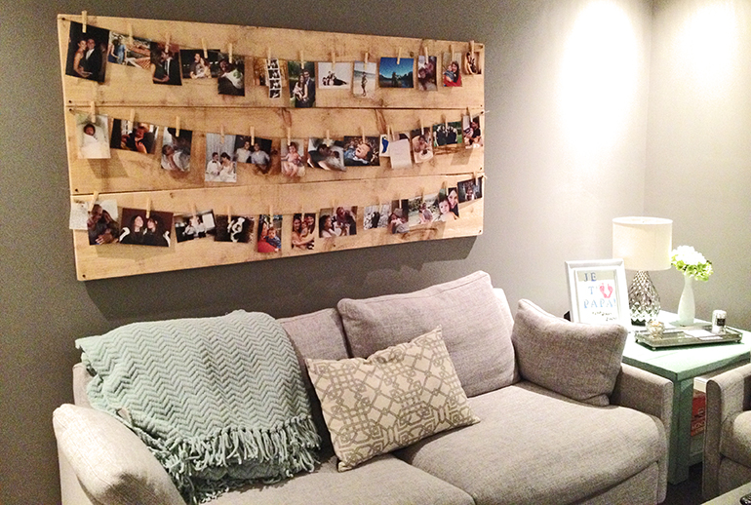
This interactive display would be a single panel in the museum where visitors would be provided with prompted feedback cards. Similar to the Greeley History Museum, visitors would be able to choose which card prompt to fill out. They would then hang them on the board provided. We can have slips of paper with various prompts:
- I am interested in this exhibit because….
- My family celebrates our culture through…
- ….And one other

Where in the world is Carmen Sandiego/Where’s Waldo?
- Children Scavenger Hunt
Calling upon the children’s show and popular puzzle book, this interactive would engage our younger visitors. We would ask the visitors to keep an eye out for a specific person/item that continues throughout the exhibit and have them keep track on an exhibit map (handed out by the greeter) marking the location and significance of the item within the exhibit. Depending on how involved we would like to make this interactive, the visitors who find all the items could be entered into a drawing for a gift card at the close of the exhibit.

What if you could only bring one suitcase?
- Photographs, Heirlooms, Clothes
- Bringing heirlooms or bringing practical items? Why so?
The act of immigrating and moving around often required people to get very selective about what they wished to take with them. We want to simulate this this activity by providing guests with a single suitcase and a large variety of items to pack in it. By encouraging visitors to think critically about what they would bring with them is they were limited on space, we prompt them to consider what their individual priorities would be if they had to immigrate to a new place. Will participants be more interested in bringing their own culture with them and bring heirlooms/etc., or will they place emphasis on starting from scratch and just bring the bare essentials. We could also include items that are specific to life in Colorado, like jackets or warm clothes.

“Before and Now Guessing Game”
- We can use repeat photography to create a panel of photos of historic structures in Fort Collins with links to immigration. We would have a question of some sort
  - Guess what this building used to be.
  - Guess who opened a business in this building in 1900?
  - Etc.
  - 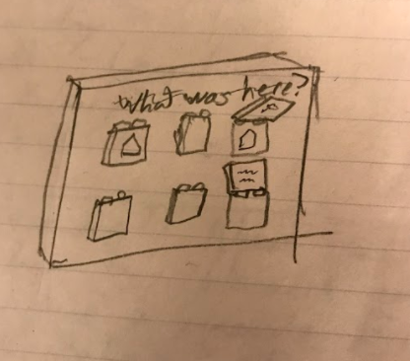
    - (photo credit- Joe Obviously)
- Each photo will have a flap and when you open it, the answer to the question will be revealed.
- If you want to see an “old photo of the inside of this building,” “an inventory record,” etc, go on our walking tour!
- This will work well to make the most of the restaurant/local business research we are completing.
  - Walking Tour-collaboration w media team
This is another interactive piece consisting of a custom-made (probably plywood) panel with numerous smaller panels attached to the front of it. These smaller panels would contain an image/photo of a historic restaurant/building/location with an identification and will probably flip upwards, revealing a historic version of that picture with information on the building’s past and association with immigration. This will tie into our larger walking tour and prompt visitors to go out and find the actual site. This particular exhibit could also appeal to people who cannot (or do not want to) go out into the community, as well as younger patrons who might find the guessing game amusing.

QR Codes- Making information available online
This interactive is minimal (flat, incorporate into labels) and catered to our visitors with mobile devices. The QR codes could connect our visitors beyond the exhibit to related websites, online archives, digital repositories, etc. or to our website/resources. Depending on how many artifacts and objects we use in our exhibit, we could connect QR codes to objects related to the displayed objects that we either have not space for or did not deem relative to our Big Idea.

Next Steps:
- Create list of needed items for finalized activity list and submit to Supply Manager
- Determine preferred location of activities and submit to exhibit design team, mount and display team
- Create list of needed collaborations (media, communication, education team)

